Batch: D - 1 Roll No.: 16010122096

Experiment / assignment / tutorial No. 04

Grade: AA / AB / BB / BC / CC / CD /DD

Signature of the Staff In-charge with date

TITLE: Project Plan document for Mini Project

AIM: To learn and understand the way of developing the software by classical methods of software engg., Planning and monitoring of the project using tools and prepare a document for the same by using the concept of software engineering ______________________________________________________________________
Expected OUTCOME of Experiment:

_____________________________________________________________________
Books/ Journals/ Websites referred:

1. Roger Pressman, Software Engineering: A practitioners Approach, McGraq Hill, 2010 ,6th edition
2. Ian Somerville , Software Engineering , Addison Wesley,2011,9th edition
- http://en.wikipedia.org/wiki/Software_requirements_specification

_____________________________________________________________________

Software Project Management Plan
for
<Name of Project>
<author>
<date>
Version | Release Date | Responsible Party | Major Changes
0.1 |  |  | Initial Document Release for Comment
Table of Contents
Build the table of contents here. Insert it when you finish your document.
1. Introduction
This section of the SPMP provides an overview of the project.
1.1 Project Overview
Include a concise summary of the project objectives, major work activities, major milestones, required resources, and budget. Describe the relationship of this project to other projects, if appropriate. Provide a reference to the official statement of product requirements.
1.2 Project Deliverables
List the primary deliverables for the customer, the delivery dates, delivery locations, and quantities required satisfying the terms of the project agreement.
1.3 Evolution of the SPMP
Describe how this plan will be completed, disseminated, and put under change control. Describe how both scheduled and unscheduled updates will be handled.
1.4 Reference Materials
Provide a complete list of all documents and other sources of information referenced in the plan. Include for each the title, report number, date, author, and publishing organization.
1.5 Definitions and Acronyms
Define or provide references to the definition of all terms and acronyms required to properly interpret the SPMP.
2. Project Organization
This section specifies the process model for the project and its organizational structure.
2.1 Process Model
Specify the life cycle model to be used for this project or refer to an organizational standard model that will be followed. The process model must include roles, activities, entry criteria and exit criteria for project initiation, product development, product release, and project termination.
2.2 Organizational Structure
Describe the internal management structure of the project, as well as how the project relates to the rest of the organization. It is recommended that charts be used to show the lines of authority.
2.3 Organizational Interfaces
Describe the administrative and managerial interfaces between the project and the primary entities with which it interacts. A table may be a useful way to represent this.
Organization | Liaison | Contact Information
Customer: <name> | <name> | <phone, email, etc.>
Subcontractor: <name>
Software Quality Assurance
Software Configuration Management
<etc>
Table F-1. Project Interfaces
2.4 Project Responsibilities
Identify and state the nature of each major project function and activity, and identify the individuals who are responsible for those functions and activities. Tables of functions and activities may be used to depict project responsibilities.
Role | Description | Person
Project Manager | leads project team; responsible for project deliverables | <name>
Technical Team Leader(s) | <define as locally used> | <name>
<etc.> | <etc.>
Table F-2. Project Responsibilities.
3. Managerial Process
This section of the SPMP specifies the management process for this project.
3.1 Management Objectives and Priorities
Describe the philosophy, goals, and priorities for managing this project. A flexibility matrix might be helpful in communicating what dimensions of the project are fixed, constrained and flexible. Each degree of flexibility column can contain only one “X”.
Project Dimension | Fixed | Constrained | Flexible
Cost |  | X
Schedule | X
Scope (functionality) |  |  | X
Table F-3: Flexibility Matrix
3.2 Assumptions, Dependencies, and Constraints
State the assumptions on which the project is based, any external events the project is dependent upon, and the constraints under which the project is to be conducted. Include an explicit statement of the relative priorities among meeting functionality, schedule, and budget for this project.
3.3 Risk Management
Describe the process to be used to identify, analyze, and manage the risk factors associated with the project. Describe mechanisms for tracking the various risk factors and implementing contingency plans. Risk factors that should be considered include contractual risks, technological risks, risks due to size and complexity of the product, risks in personnel acquisition and retention, and risks in achieving customer acceptance of the product. The specific risks for this project and the methods for managing them may be documented here or in another document included as an appendix or by reference.
3.4 Monitoring and Controlling Mechanisms
Define the reporting mechanisms, report formats, review and audit mechanisms, and other tools and techniques to be used in monitoring and controlling adherence to the SPMP. Project monitoring should occur at the level of work packages. Include monitoring and controlling mechanisms for the project support functions (quality assurance, configuration management, documentation and training).
A table may be used to show the reporting and communication plan for the project. The communication table can show the regular reports and communication expected of the project, such as weekly status reports, regular reviews, or as-needed communication. The exact types of communication vary between groups, but it is useful to identify the planned means at the start of the project.
Information Communicated | From | To | Time Period
Status report | Project Team | Project Manager | Weekly
Status report | Project Manger | Software Manager, Project Team | Weekly
Project Review | Project Team | Software Manager | Monthly
<etc>
Table F-4: Communication and Reporting Plan
3.5 Staffing Approach.
Describe the types of skills required for the project, how appropriate personnel will be recruited, and any training required for project team members.
4. Technical Process
This section specifies the technical methods, tools, and techniques to be used on the project. It also includes identification of the work products and reviews to be held and the plans for the support group activities in user documentation, training, software quality assurance, and configuration management.
4.1 Methods, Tools, and Techniques
Identify the computing system(s), development method(s), standards, policies, procedures, team structure(s), programming language(s), and other notations, tools, techniques, and methods to be used to specify, design, build, test, integrate, document, deliver, modify or maintain the project deliverables
4.2 Software Documentation
Specify the work products to be built for this project and the types of peer reviews to be held for those products. It may be useful to include a table that is adapted from the organization’s standard collection of work products and reviews. Identify any relevant style guide, naming conventions and documentation formats. In either this documentation plan or the project schedule provide a summary of the schedule and resource requirements for the documentation effort.
To ensure that the implementation of the software satisfies the requirements, the following documentation is required as a minimum:
4.2.1 Software Requirements Specification (SRS)
The SRS clearly and precisely describes each of the essential requirements (functions, performances, design constraints, and attributes) of the software and the external interfaces. Each requirement is defined such that its achievement is capable of being objectively verified and validated by a prescribed method, for example, inspection, analysis, demonstration, or test.
4.2.2 Software Design Description (SDD)
The SDD describes the major components of the software design including databases and internal interfaces.
4.2.3 Software Test Plan
The Software Test Plan describes the methods to be used for testing at all levels of development and integration: requirements as expressed in the SRS, designs as expressed in the SDD, code as expressed in the implemented product. The test plan also describes the test procedures, test cases, and test results that are created during testing activities.
4.3 User Documentation
Describe how the user documentation will be planned and developed. (This may be just a reference to a plan being built by someone else.) Include work planned for online as well as paper documentation, online help, network accessible files and support facilities.
4.4 Project Support Functions
Provide either directly or by reference, plans for the supporting functions for the software project. These functions may include, but are not limited to, configuration management, software quality assurance, and verification and validation. Plans for project support functions are developed to a level of detail consistent with the other sections of the SPMP. In particular, the responsibilities, resource requirements, schedules and budgets for each supporting function must be specified. The nature and type of support functions required will vary from project to project, however, the absence of a software quality assurance, configuration management, or, verification and validation plan must be explicitly justified in project plans that do not include them.
5. Work Packages, Schedule, and Budget
Specify the work packages, dependency relationships, resource requirements, allocation of budget and resources to work packages, and a project schedule. Much of the content may be in appendices that are living documents, updated as the work proceeds.
5.1 Work Packages
Specify the work packages for the activities and tasks that must be completed in order to satisfy the project agreement. Each work package is uniquely identified. A diagram depicting the breakdown of project activities and tasks (a work breakdown structure) may be used to depict hierarchical relationships among work packages.
5.2 Dependencies
Specify the ordering relations among work packages to account for interdependencies among them and dependencies on external events. Techniques such as dependency lists, activity networks, and the critical path method may be used to depict dependencies among work packages.
5.3 Resource Requirements
Provide, as a function of time, estimates of the total resources required to complete the project. Numbers and types of personnel, computer time, support software, computer hardware, office and laboratory facilities, travel, and maintenance requirements for the project resources are typical resources that should be specified.
5.4 Budget and Resource Allocation
Specify the allocation of budget and resources to the various project functions, activities, and tasks.
5.5 Schedule
Provide the schedule for the various project functions, activities, and tasks, taking into account the precedence relations and the required milestone dates. Schedules may be expressed in absolute calendar time or in increments relative to a key project milestone.
6. Additional Components.
Certain additional components may be required and may be appended as additional sections or subsections to the SPMP. Additional items of importance on any particular project may include subcontractor management plans, security plans, independent verification and validation plans, training plans, hardware procurement plans, facilities plans, installation plans, data conversion plans, system transition plans, or the product maintenance plan.
6.1 Index.
An index to the key terms and acronyms used throughout the SPMP is optional, but recommended to improve usability of the SPMP.
6.2 Appendices
Appendices may be included, either directly or by reference, to provide supporting details that could detract from the SPMP if included in the body of the SPMP. Suggested appendices include:
A. Current Top 10 Risk Chart
B. Current Project Work Breakdown Structure
C. Current Detailed Project Schedule

Gantt Chart for Online Vehicle Booking Platform:
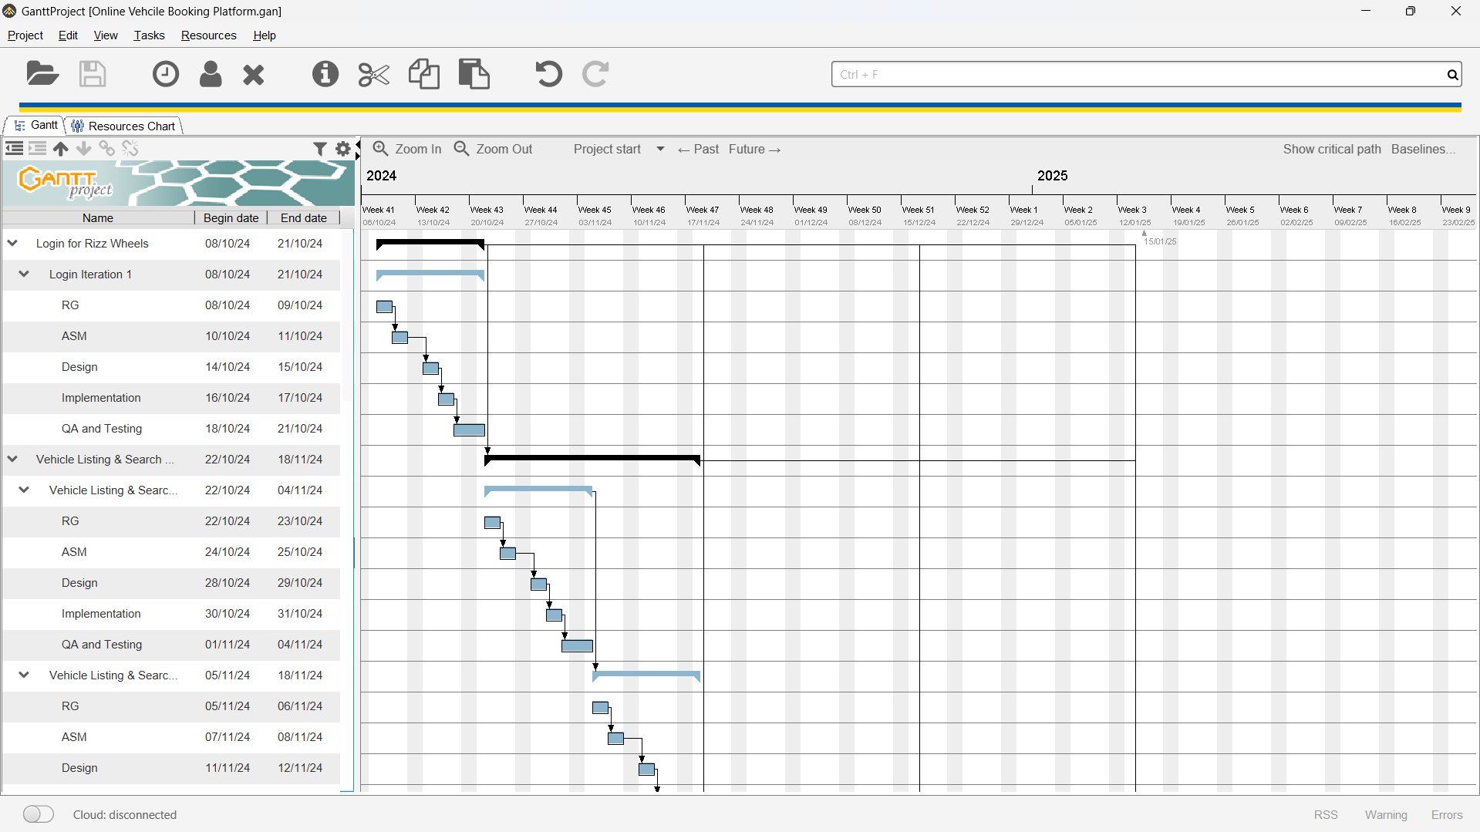
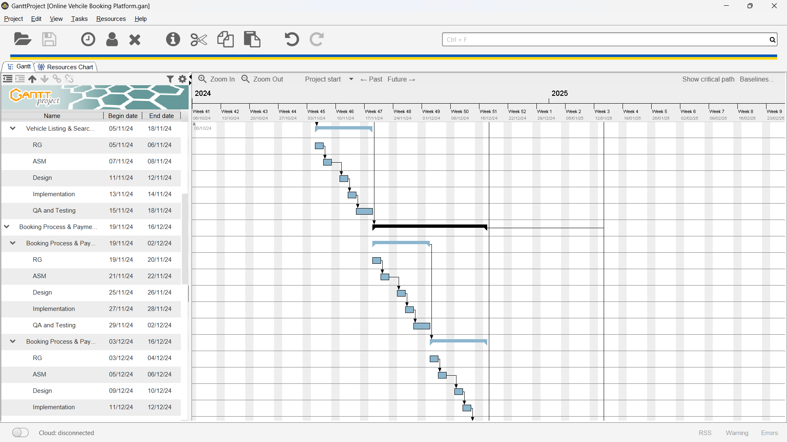
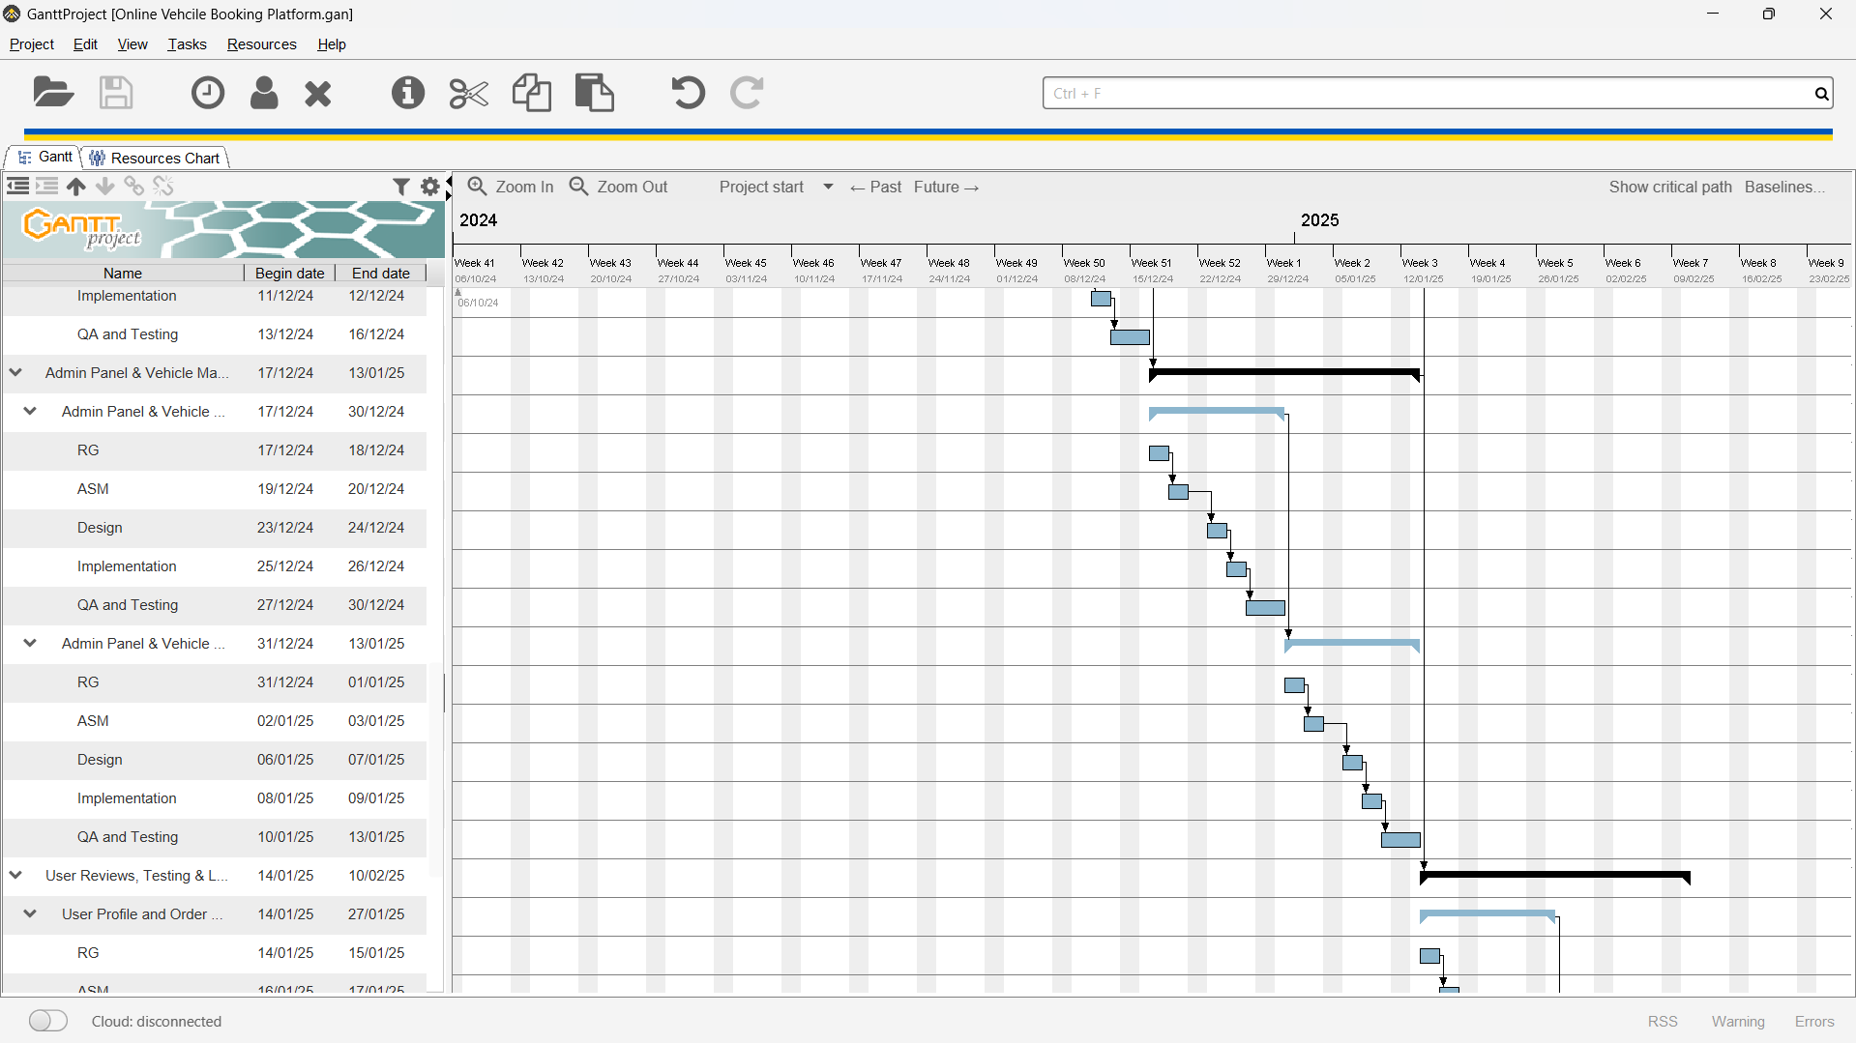

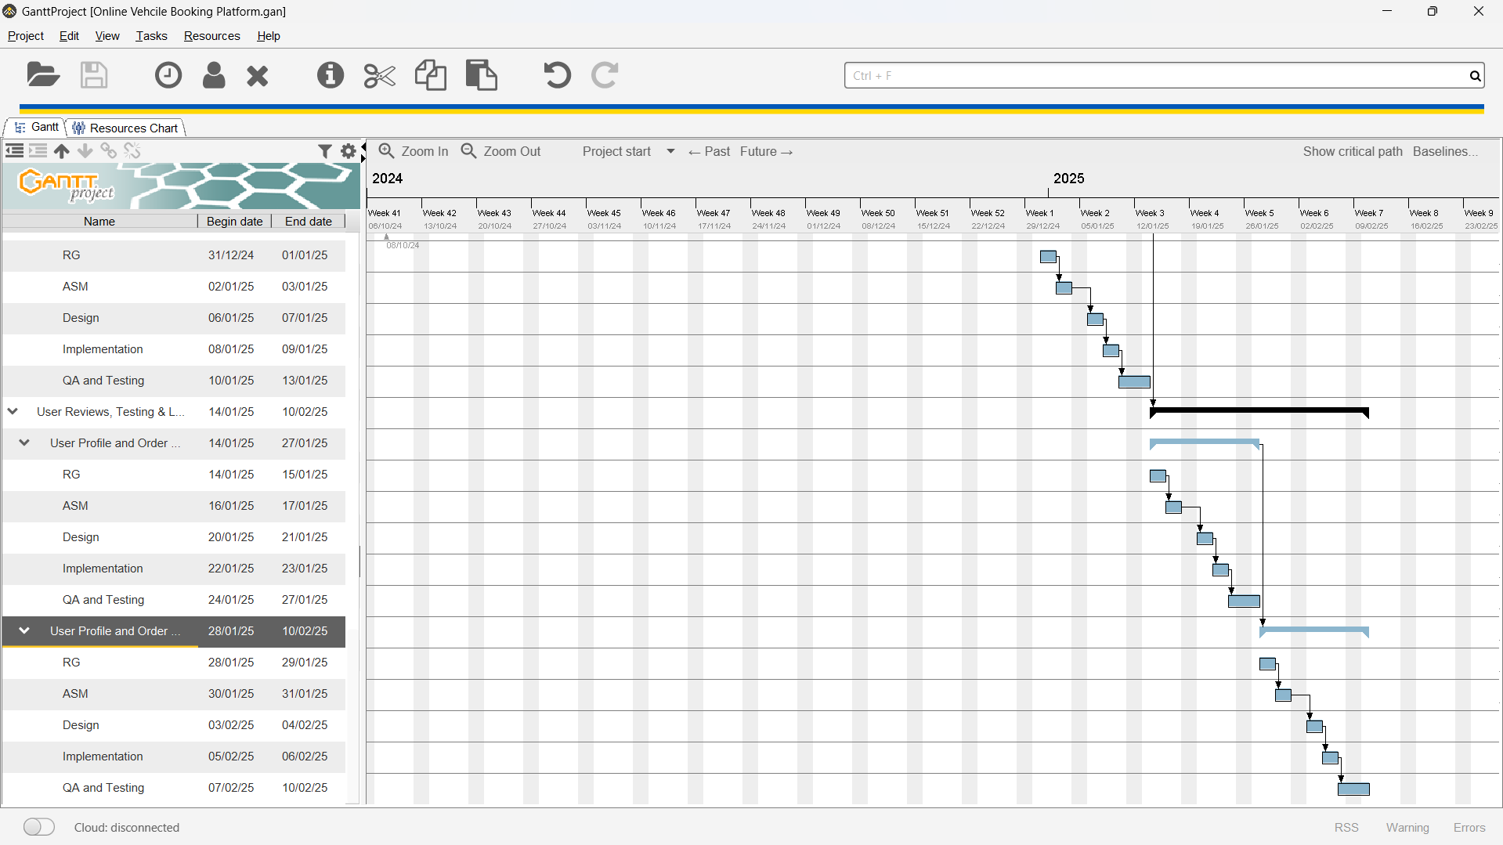
Conclusion:
This project enhances understanding of classical software engineering methods, emphasizing effective planning, monitoring, and documentation throughout the development process.

Post Lab Descriptive Questions
- State various Scheduling principles and explain them in detail.
Scheduling Principles in Software Engineering
- Priority Scheduling
Assigns priorities to tasks based on their importance or urgency. Higher-priority tasks are executed before lower-priority ones. This ensures critical tasks are completed first, but it can lead to starvation for lower-priority tasks if they are continuously preempted.
- Round Robin Scheduling
Each task is assigned a fixed time slot in a cyclic order. This method promotes fairness by ensuring all tasks receive equal CPU time. It’s effective in time-sharing systems but can lead to increased turnaround time for longer tasks.
- First-Come, First-Served (FCFS)
Tasks are scheduled in the order they arrive. This method is simple and easy to implement but can lead to the "convoy effect," where shorter tasks are delayed by longer tasks, increasing overall waiting time.
- Shortest Job Next (SJN)
The task with the smallest execution time is scheduled next. This minimizes average waiting time and is optimal for minimizing turnaround time. However, it requires knowledge of the execution time in advance, which is often impractical.
- Longest Job First (LJF)
The longest tasks are scheduled first, which can be beneficial in certain contexts but is generally inefficient as it may lead to increased waiting times for shorter tasks. It is less common in practice.
- Multilevel Queue Scheduling
Tasks are divided into different queues based on their characteristics (e.g., priority, type). Each queue can have its own scheduling algorithm, allowing more flexibility in handling different task types. However, this can add complexity to the scheduling process.
- Multilevel Feedback Queue Scheduling
Similar to multilevel queue scheduling, but tasks can move between queues based on their behavior and requirements. This dynamic approach allows the system to adapt to the varying nature of tasks, improving responsiveness and efficiency.
- Least Recently Used (LRU)
This principle is often applied to caching but can also inform task scheduling. Tasks that haven’t been used recently are considered less likely to be needed in the near future, allowing the scheduler to prioritize more frequently used tasks.
Understanding these scheduling principles is essential for effective project management in software engineering, as they directly impact resource allocation, task prioritization, and overall project efficiency.

